**GIT & GITHUB**

**What is version control?**

Version control is the management of changes to documents, computer programs, large websites, and other collections of information. These changes are generally termed as versions

Always version control system will have a backup of all versions or every modification. We can roll back the previous version when something issue happened in the current version

**Why version control?**

For collaboration of individual work of each developer. Version control system provides a work space to make changes by individuals Effective visualization of every ones work and changes done. So all the work done by each developer will easy to combine and manage

**Storing versions:**

* To store every version in local machine is difficult to maintain
* Using version control system, it will maintain every version organized. It will implicitly names every version, changes done

**Backup:**

* Version control system always facilitates the backup of the code

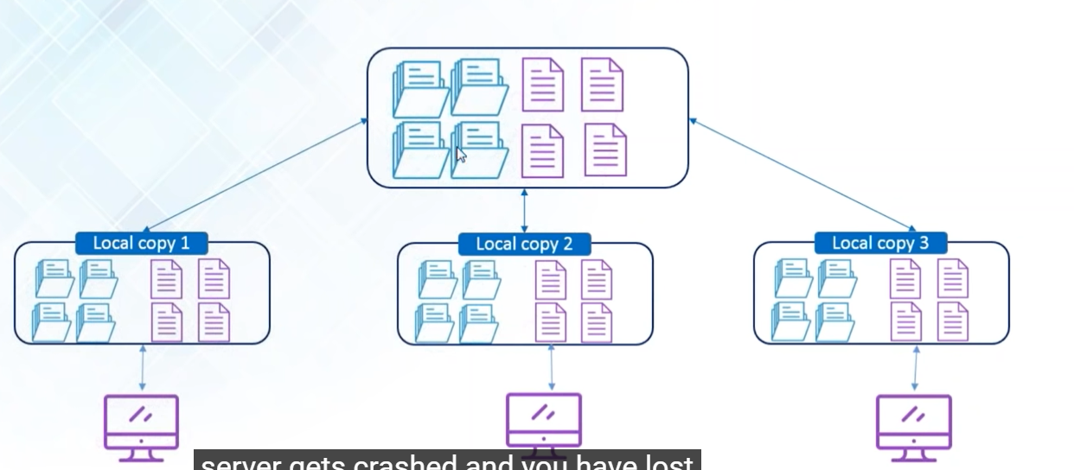

* With this maintaining local copies have the advantage when the central sever crashes we will have a backup of local copy

**Different version control tools in the market:**



Git is distributed version control system

CVS, Sub version is centralized version control systems, they will allow to push the code to directly central server there will be no local backup

**Git & Github:**

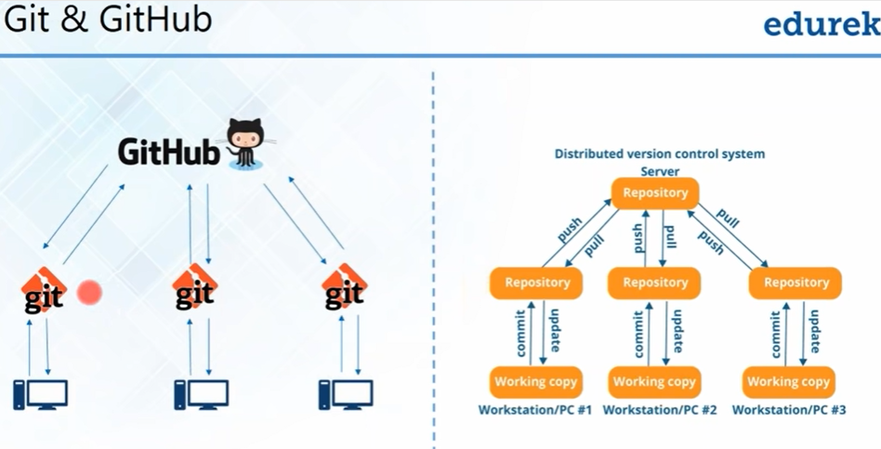

* Here the changes done in the code will pushed to local repository and then it will be pushed to central repository
* Basically pushing the code to local repository termed as commit and transferring it to central server is called as push

**Difference B/W Git & Github:**

**Git 🡪 it’s a version control management tool which perform the committing changes in code to local repository and pushing code to central repository (Github) , fetching data from central repository to local**

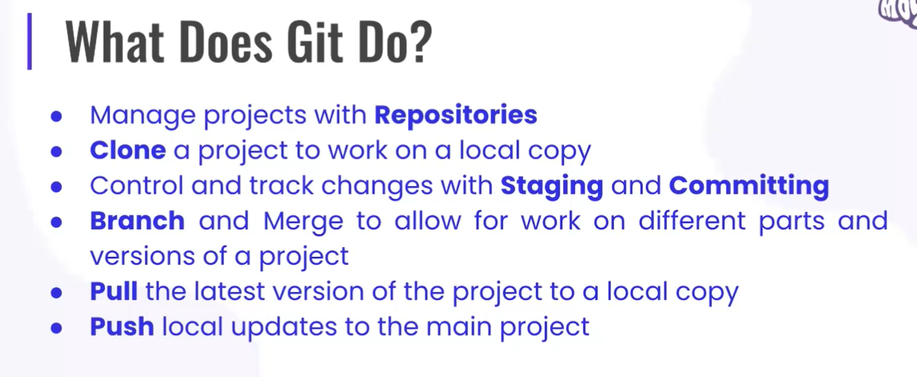

**Github --? It’s a code hosting platform for version control collaboration. It’s a company which allows host your central repository in remote server. It’s social network where everyone code will be centralized and there will be access to others and they can pull the code and make changes in their local**

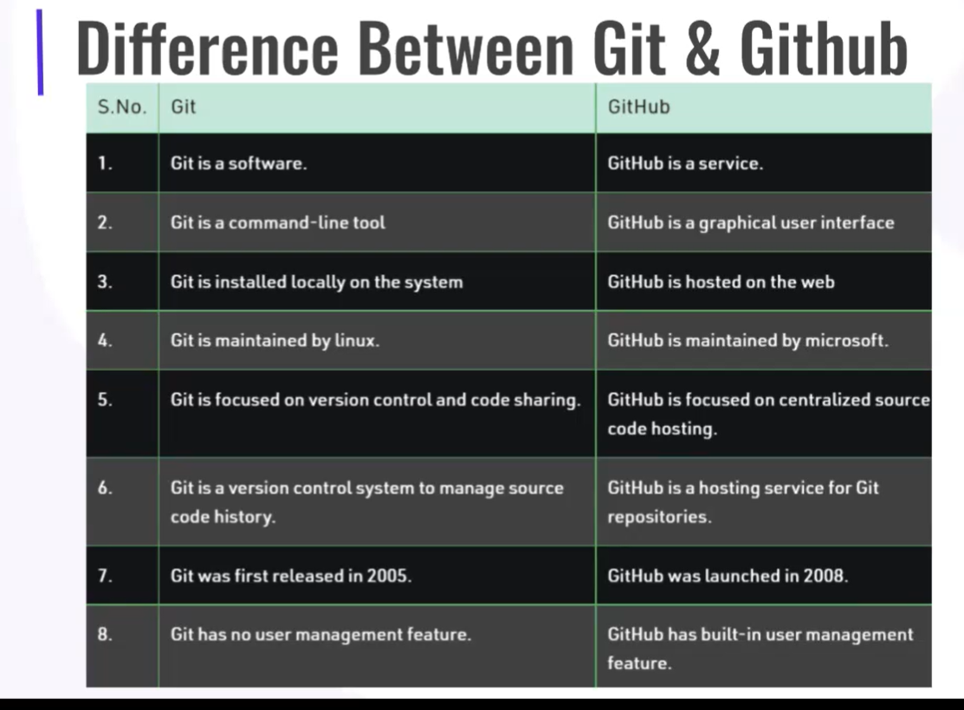

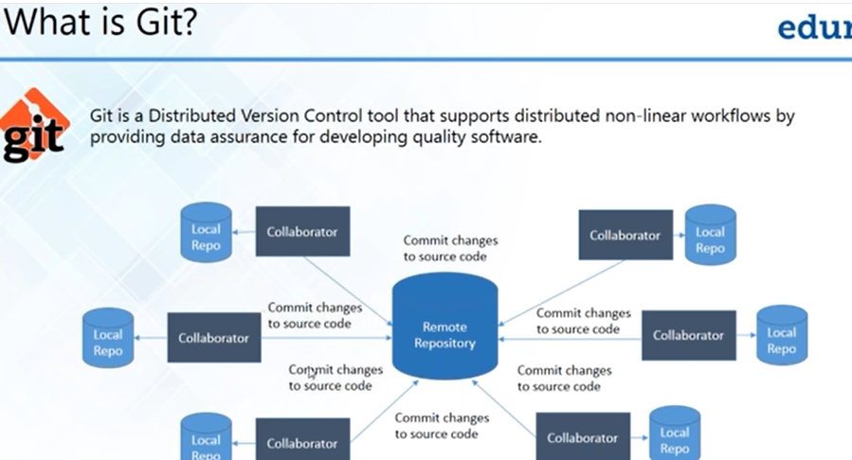

**Features of Git:**

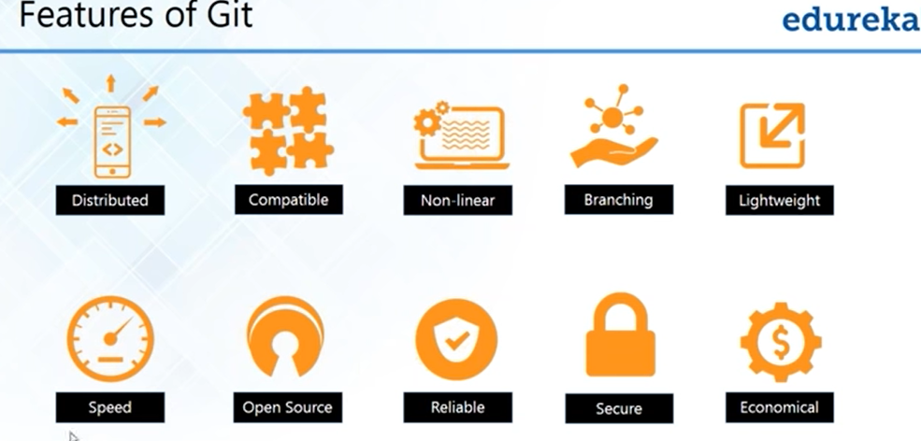

**Distributed:**

* **Allows distributed development of code**
* **Every developer has a local copy of all development history and changes are copied from one repository to another**
* **In simple words its distributed in local and distributed in world wide for all other who will have the access to repository**

**Compatible:**

* **It compatible with existing systems and protocols**
* **When you are migrating to git from another system you don’t need to do much changes in local system**

**Non linear:**

**Supports branching**

* **Supports multiple local branches and remote branches also**
* **Master branch always contains production quality code**

**Lightweight:**

**Use lossless compression technique to compress at clients side**

**Speed:**

* **Fetching data from local repository is 100 times faster then remote repositary**
* **Git is 10 times faster then other version control systems. The reason is Git is developed in C and C is very close to machine language. And it reduces all the run time overheads and it makes all the processing very fast**
* **Git is very small and very fast**

**Open source:**

* **You can modify its source code according your needs**

**Reliable:**

* **On events of system crash the lost data can be easily recovered from any of the local repositories of collaborators**

**Secured:**

* **Uses SHAI to name and identify objects**
* **The same SHAI is used by National security agency of USA**

**Economical:**

* **Released under general public license . Its for free**
* **All heavy lifting is done on client side. Hence a lot of money is saved on costly servers**

**Repository:**

**A direct or storage space where your projects can live. It can be local folder on your computer, or it can be a storage space on github or some other host. You can keep, image files, code files, text files, you name it inside a repository**

**There are two types of repositories:**

* **Central repository**
* **Local repository**

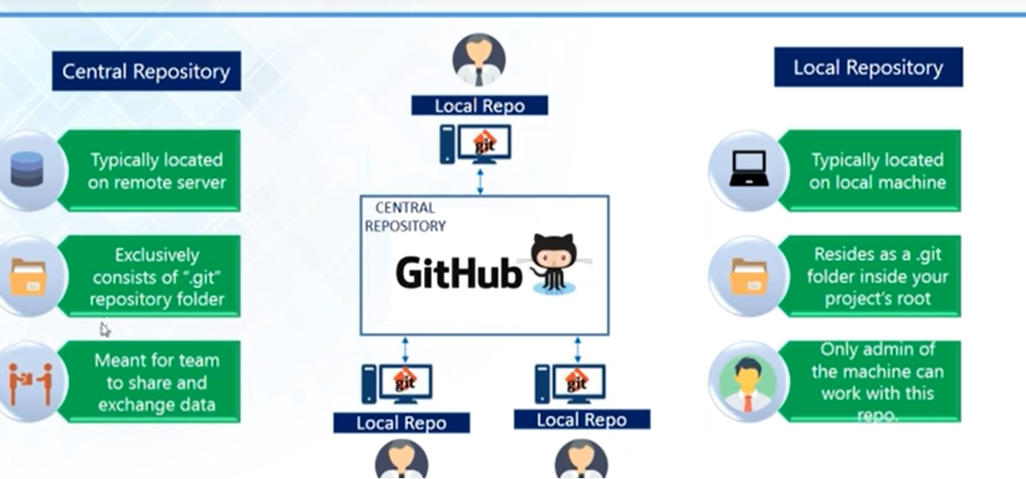

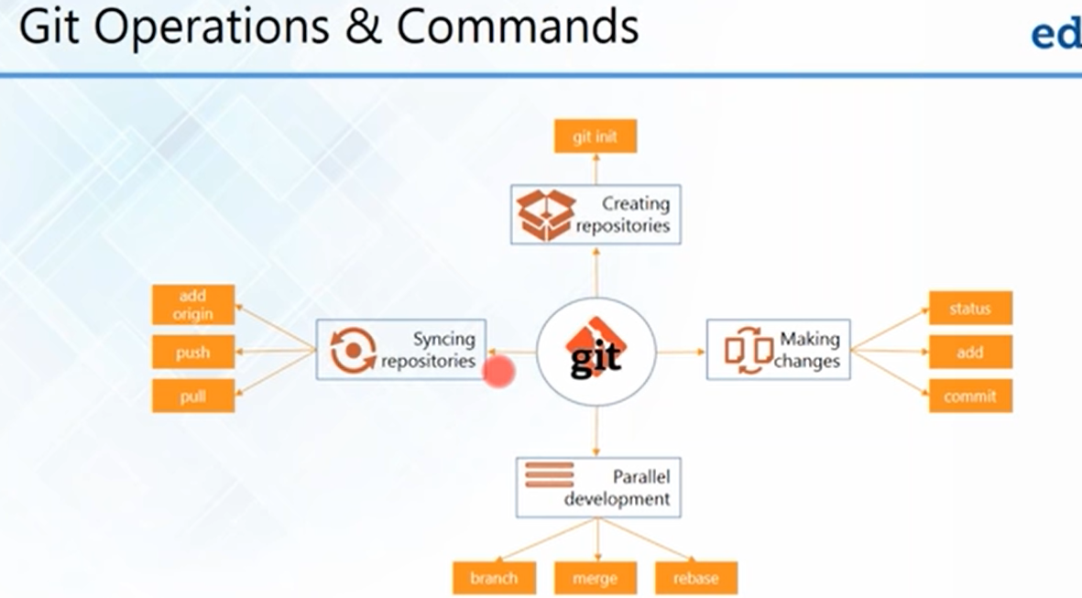

**Creating repositories:**

**Git init:**

**Install Git on your local machine and use “git init” to create your local repository.**

**Git clone:**

**Download or clone your repository from github**

**Sighing up github and creating repository:**



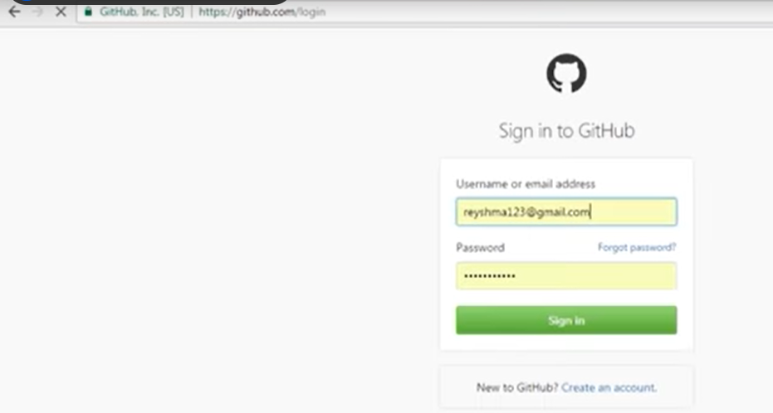

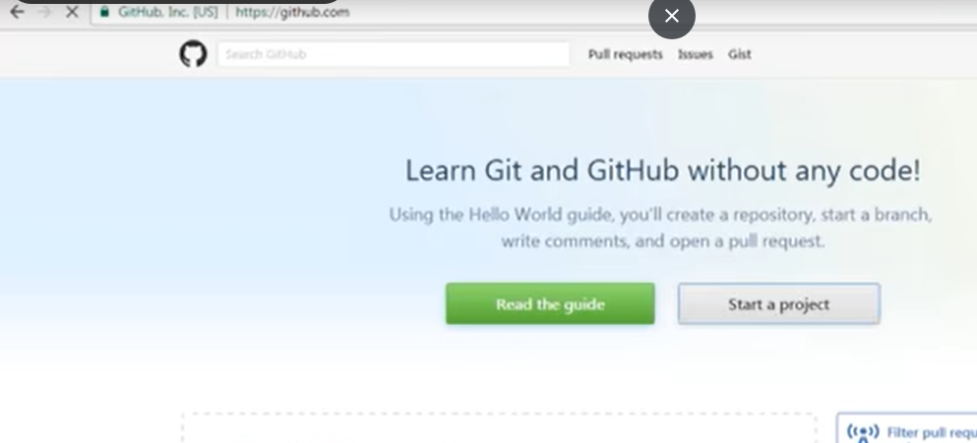

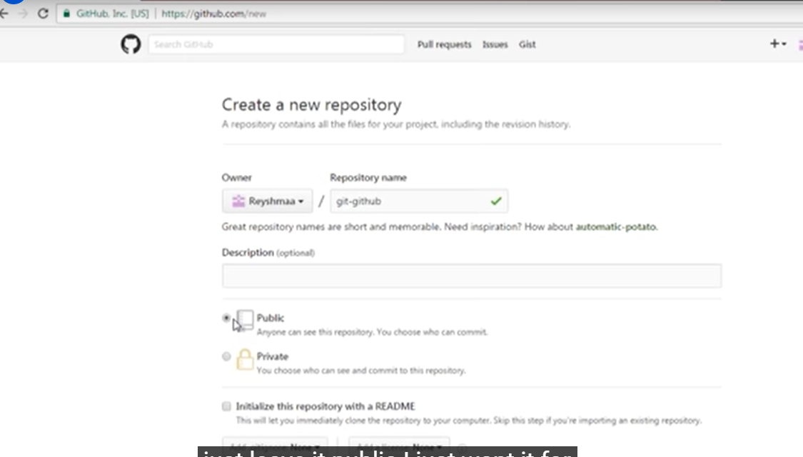

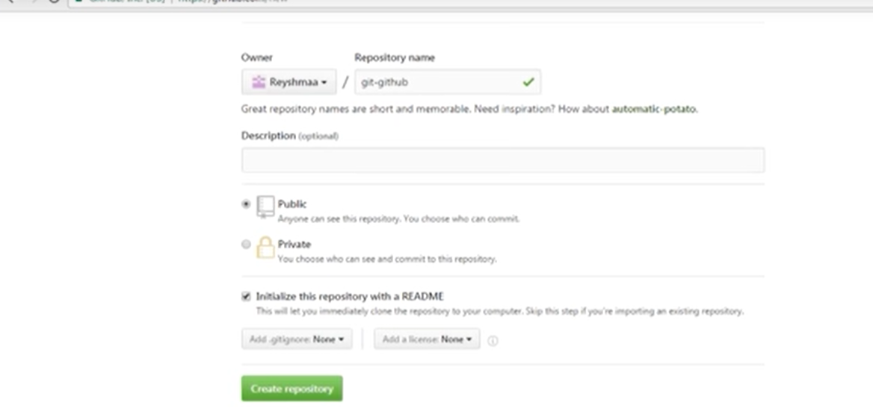

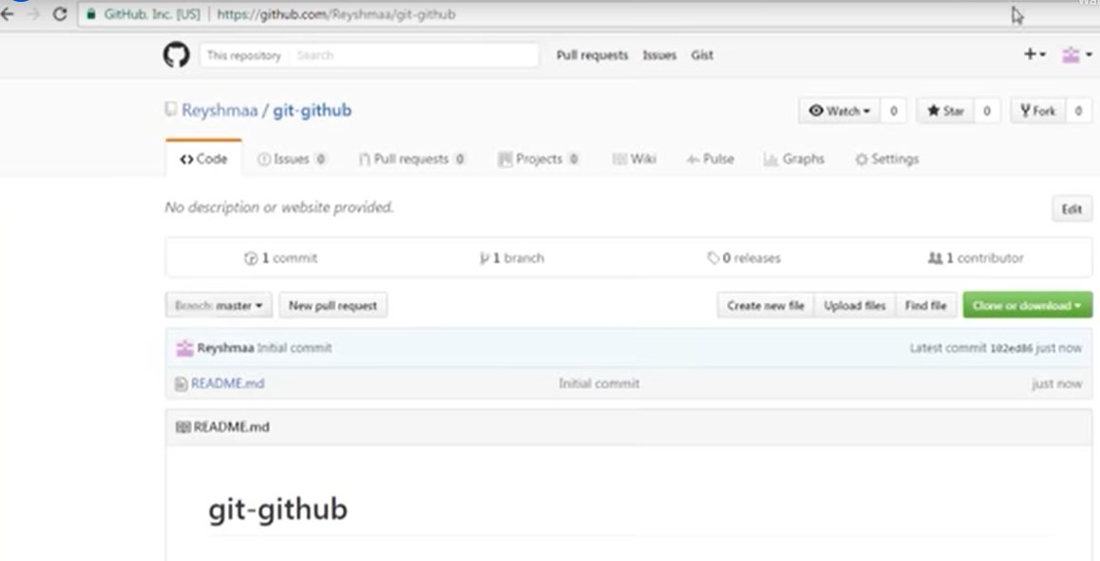

**Creating local repository:**

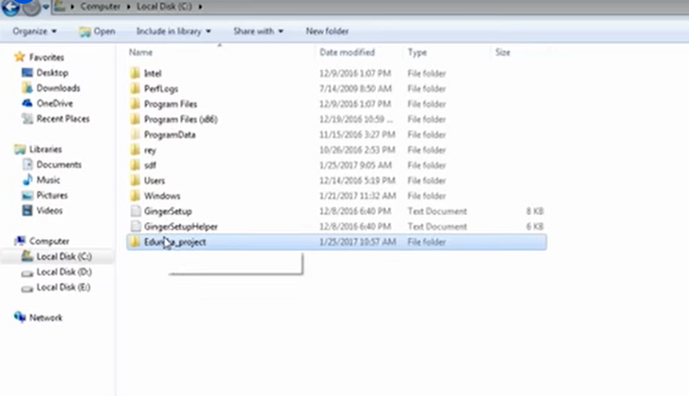

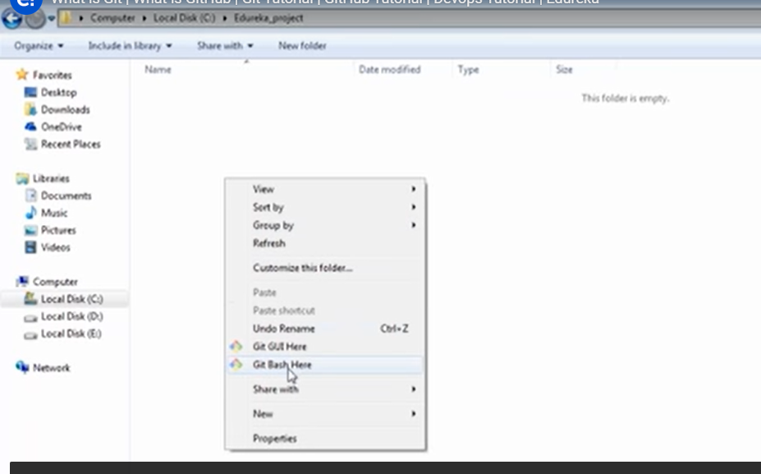

**Entering git init command in git bash command prompt to create a local repository:**

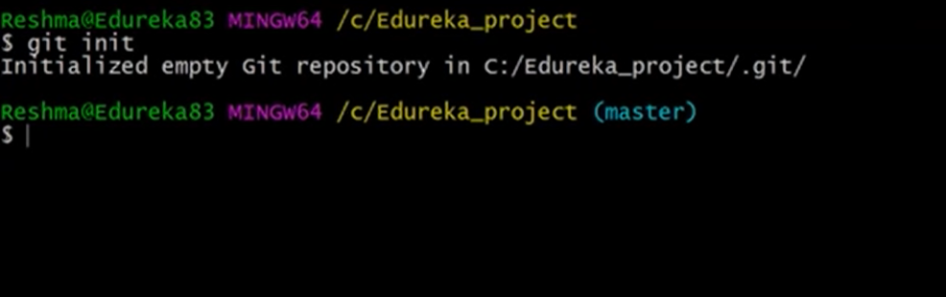

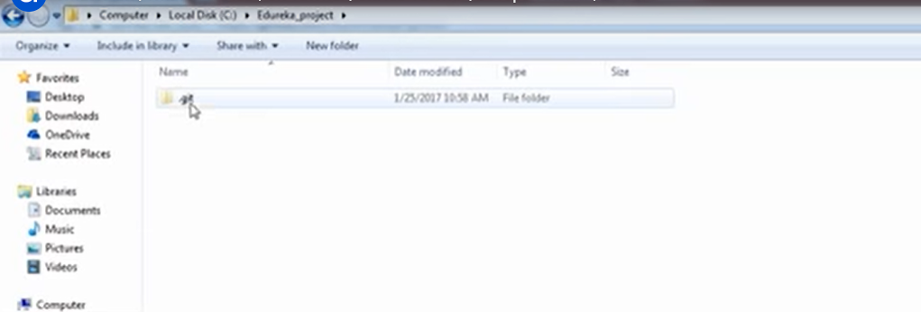

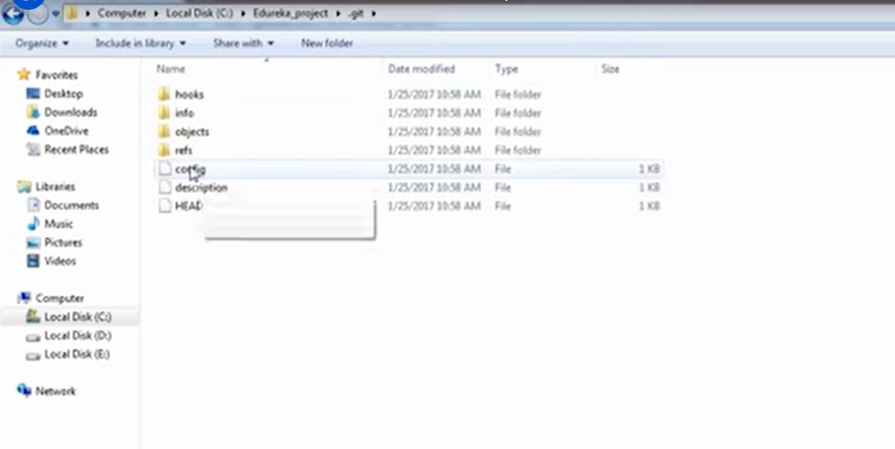

**Synching repositories:**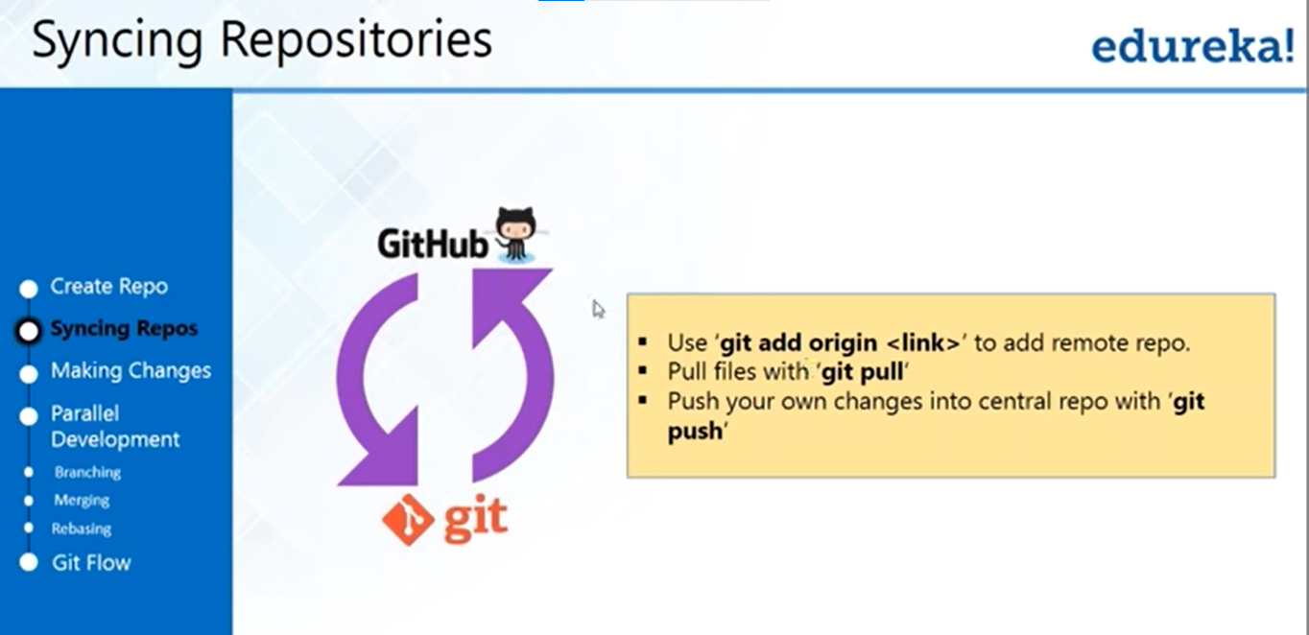

* **Copy the github repository link from the github and use the git add origin <link> to add remote repository**
* **Push file with git pul**
* **Push your own files to central repository with git push**

**Copying repository link from the Github:**

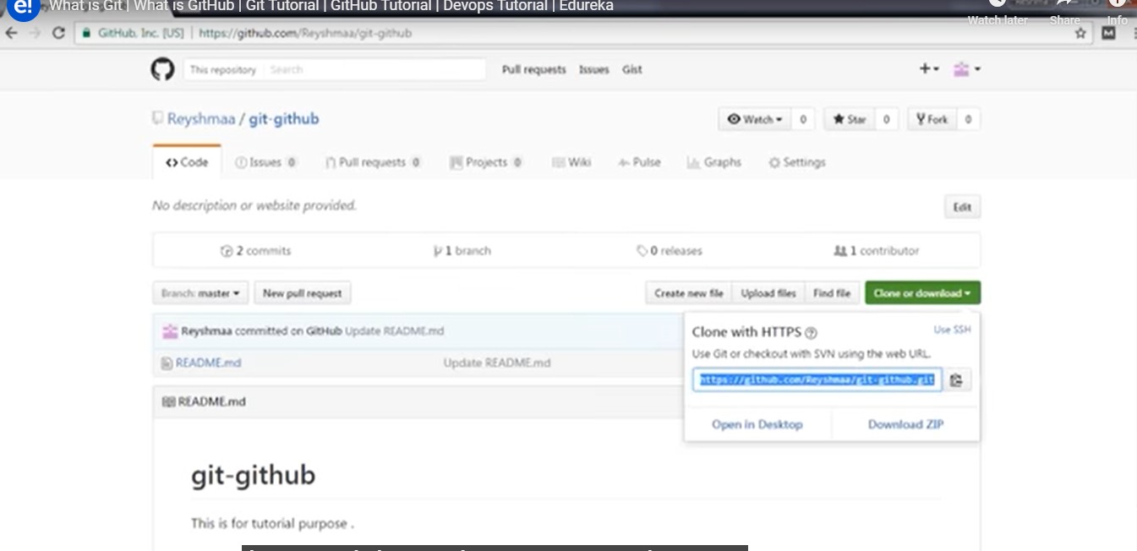

**Entering repository synch command in gitbash command prompt:**

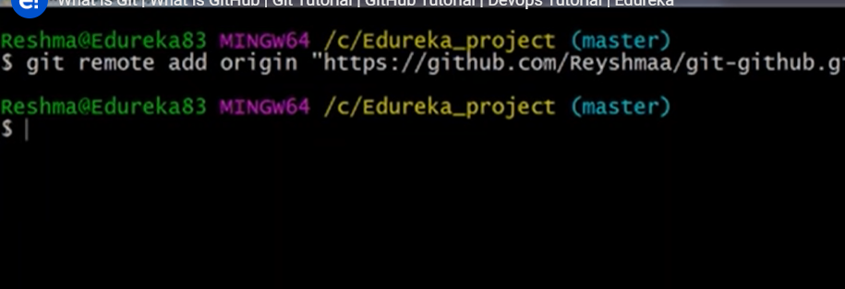

**Pulling files from central repository to local:**

* **Git pull origin master**

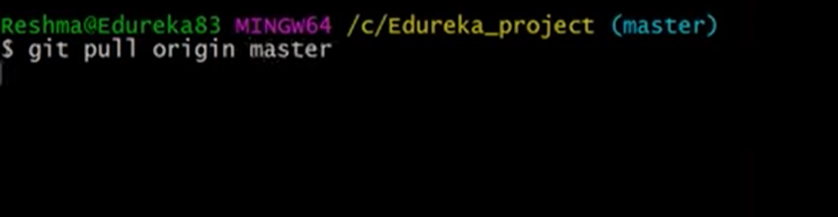

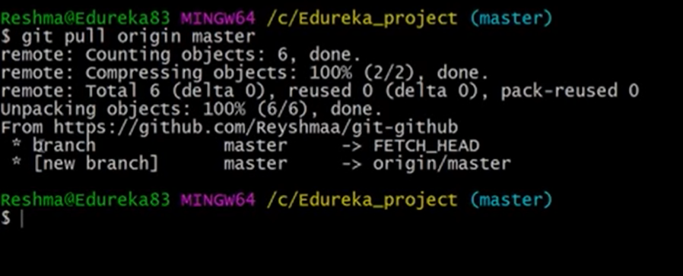

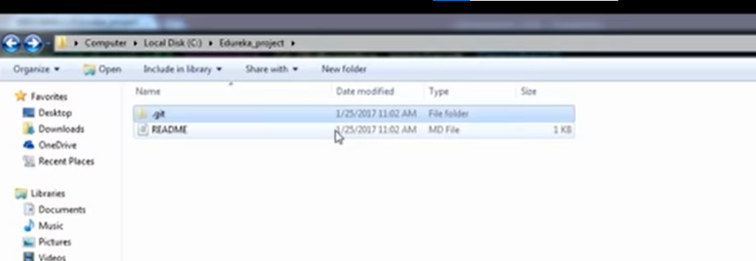

**Making the changes:**

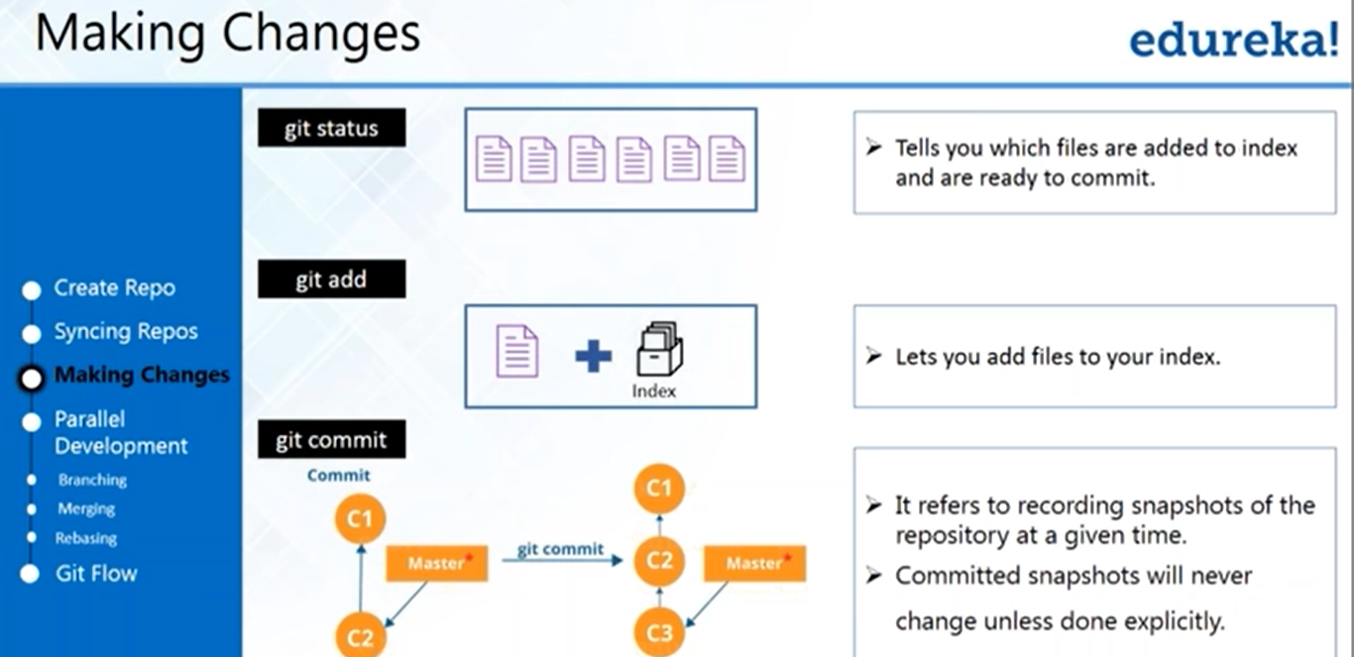

**Git status:**

* **Tell us which files are added to indeed=z and ready to commit**

**Git add:**

* **Adds files to index**

**Git commit:**

* **Its refer to recording snapshots of the repository at a given time**

**Making changes and adding files to index explicitly:**

* **Create a file and add some data]**
* **Check the “git status” commad in git bash command prompt whether created file showing or not**
* **Then do “git add file name” to add the file to index**
* **Then do “git commit -m “messege for commiting” 🡪 while commiting commit messege mandatory**

**Example:**

**Creating a file and data in local repository folder**

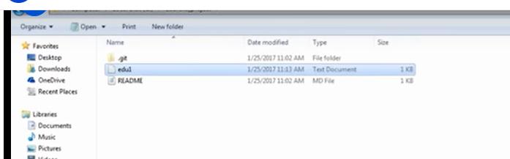

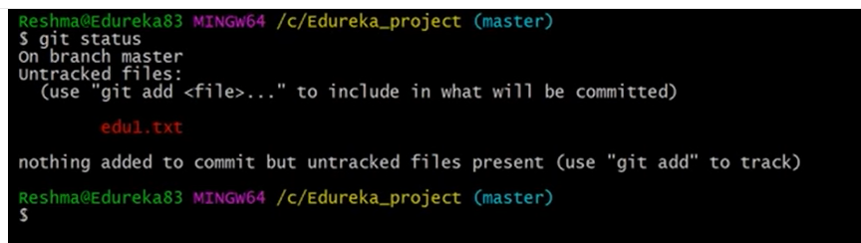

* **It showing unchecked file which recently created and we not added to index explicitly**
* **Now we will add explicitly to index**



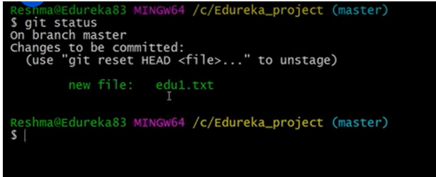

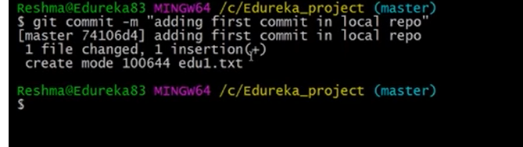

**Adding multiple files to index and commiting it:**

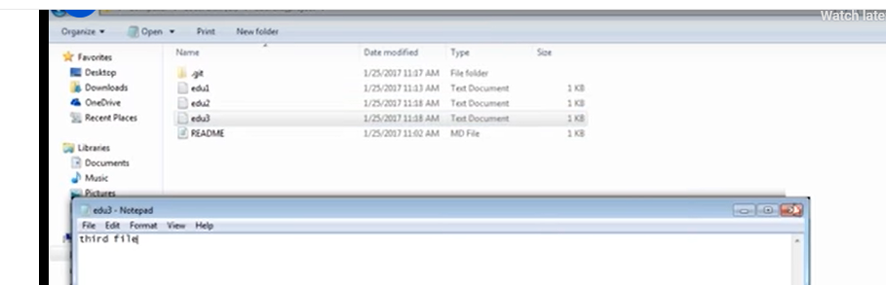

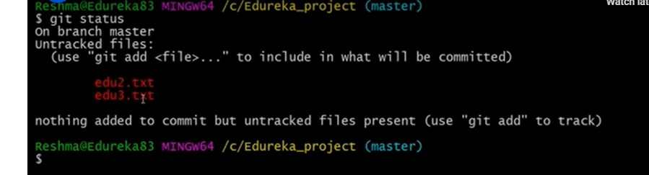

* **Adding some data in third file and checking status**

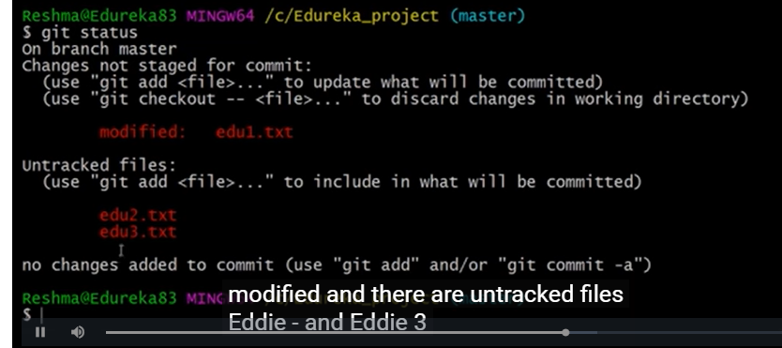

**Adding multiple files to index:**

* **Git add –A**

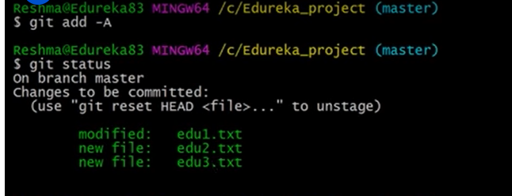

**Commiting multiple files at once:**

* **Git commit –a -m messege “commit messege”**

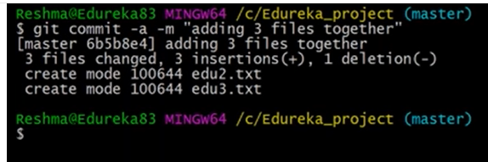

**Checking commit logs:**

* **Git log**

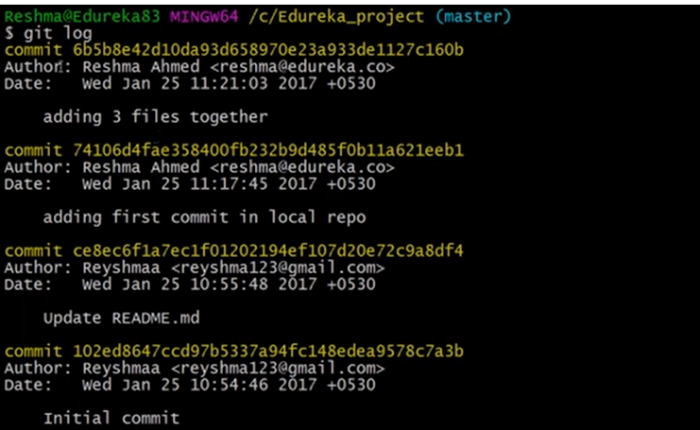

**Parallel development branching:**

* **Branches are pointer to a specific commit**
* **Branches are of two types**
  + **Local branches**
  + **Remote tracking branches**

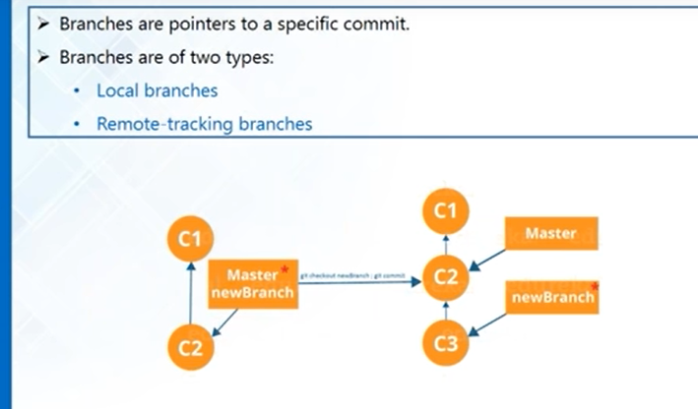

**To create a new branch In local repo:**

* **git branch branch name**

**switching to new branch**

* **git checkout switching_branch_name**

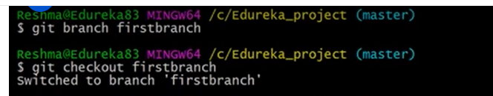

**Adding new files and commiting changes:**



**To list all files in a branch**

* **ls**

**Switching to master branch and checking whether changes in new branch reflecting it to master or not (it should not reflect):**

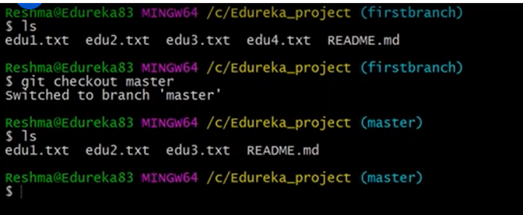

**Merging branches:**

* **git merge desired_branch_name 🡪 the desired branch files will merge it with master branch automatically**

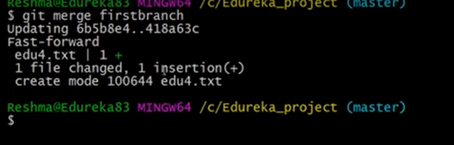

* **cat file_name shows modification done in a file**

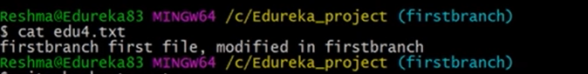

**Git pull will takes the changes and files from the central repo and added it in local repo. But git fetch will takes the files from central repo and added it in a branch in local repo not current workflow of local**

**Rebassing:**

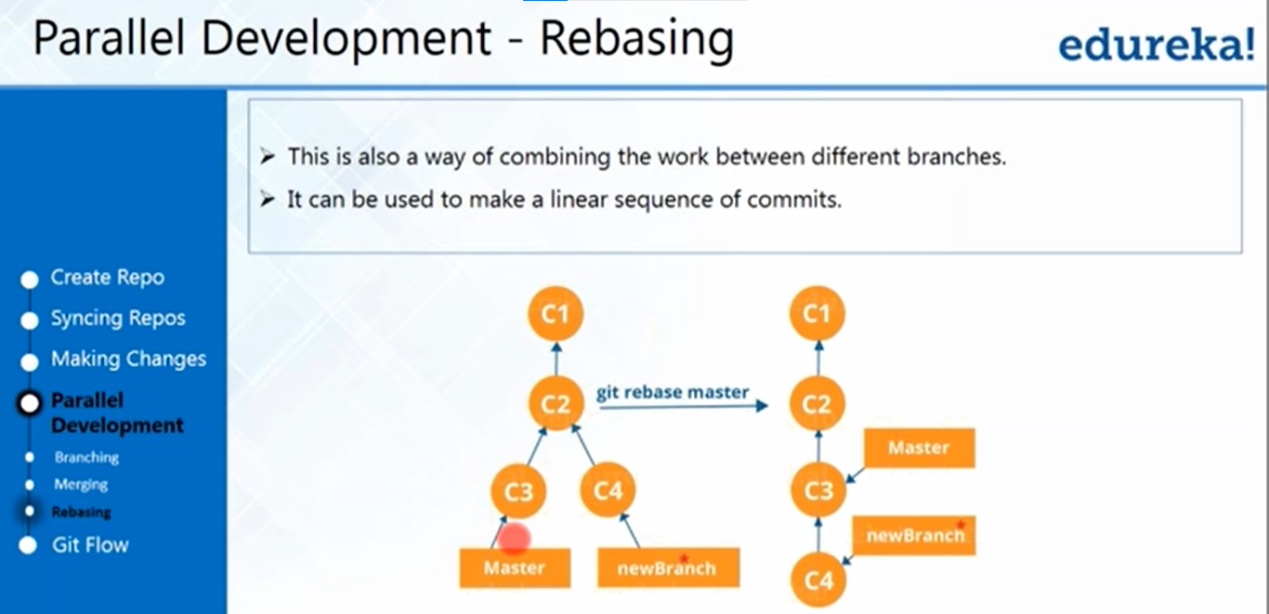

* **it will add the commits to a branch base on top of it**

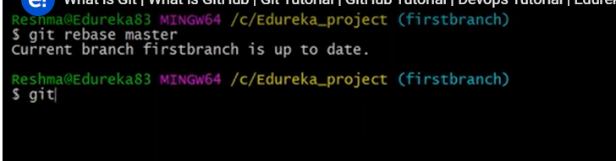

**Pushing from local repo to central repo:**

* **Before pushing a code to central repo you make sure if your central repo is public access one there will be a problem of taking a chance by other people will make a code mess and pushing their code to your branch. So prevent that create a SSH key from git tool and that key to your github central repo and authenticate it in git tool**

**Generating a SSH key from the git tool:**

* **ssh-keygen**

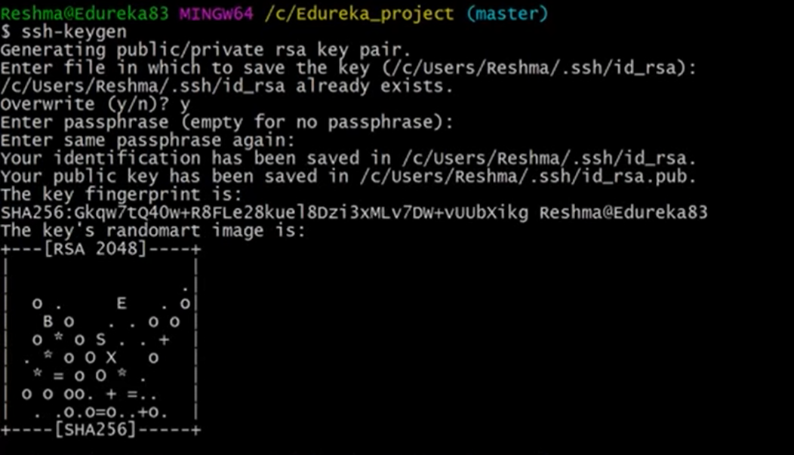

**Getting generated SSH key:**

* **cat ssh key stored folder**

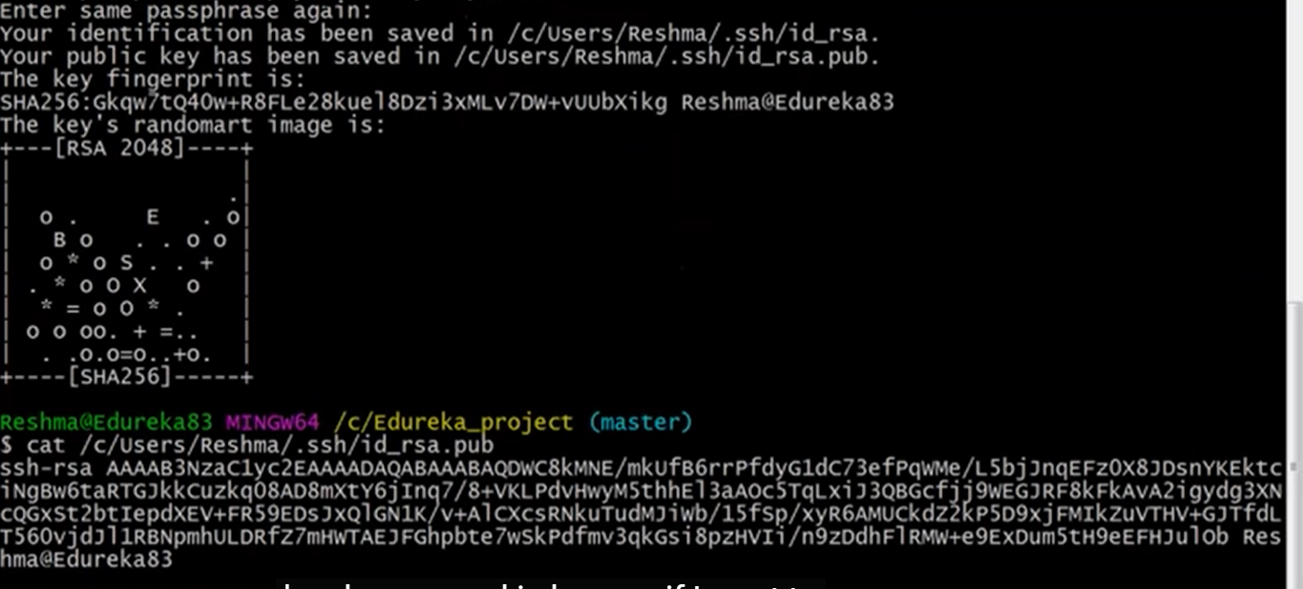

* **copy the ssh key and go back into github account and go to settings and click on SSH & GPG section at left side and click on new SSH key button and name the ssh key & paste the ssh key copied and submit**
* **and now you need to do authenticate the ssh key created ssh – T** [**git@github.com**](mailto:git@github.com)

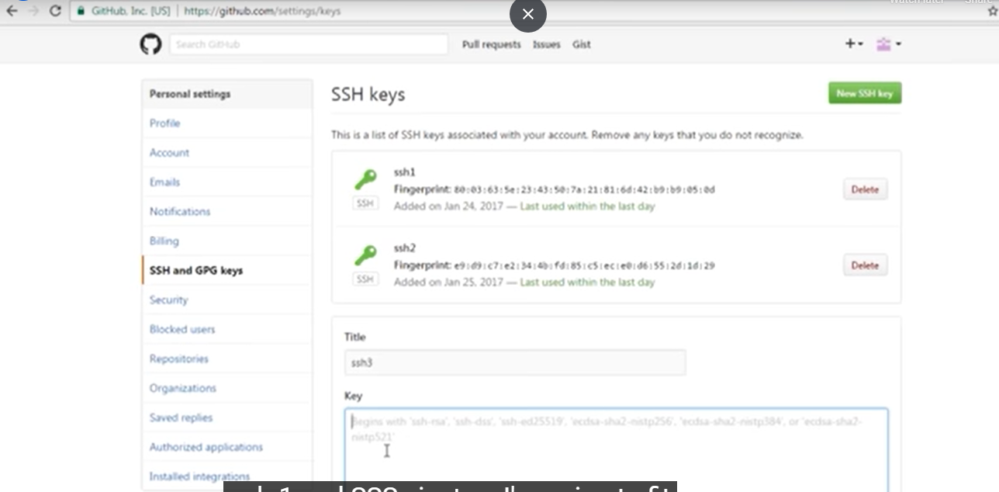

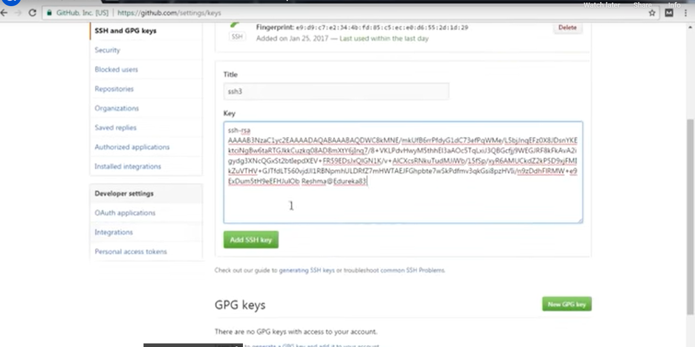



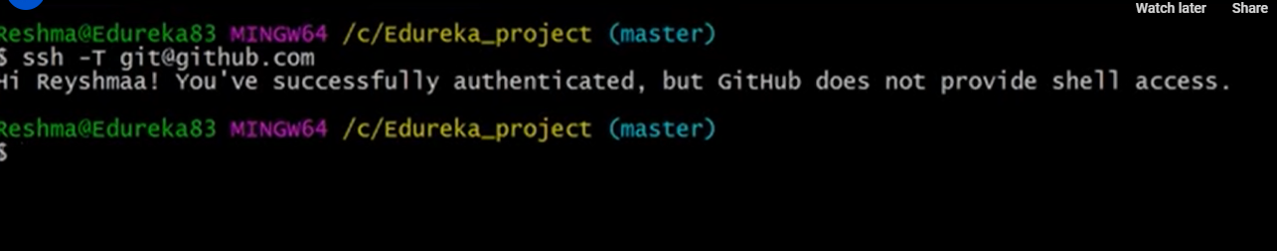

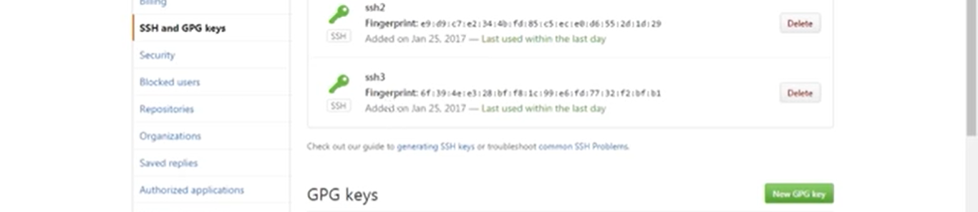

* **Now the new key authenticated**

**Now you don’t want to push the local branch files directly to your master, while you can push by creating a new branch in central repo**

**Pushing from local new_branch to central new_branch:**

* **Switch to new_branch**
* **git push origin new_branch**

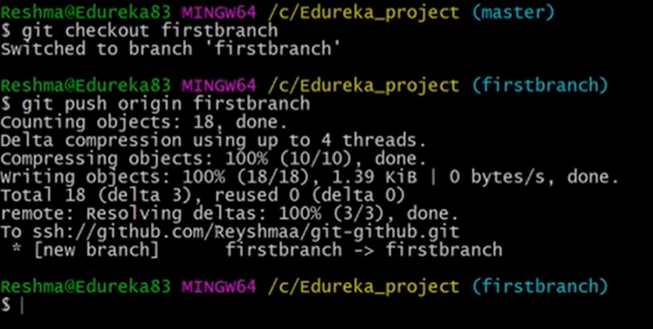

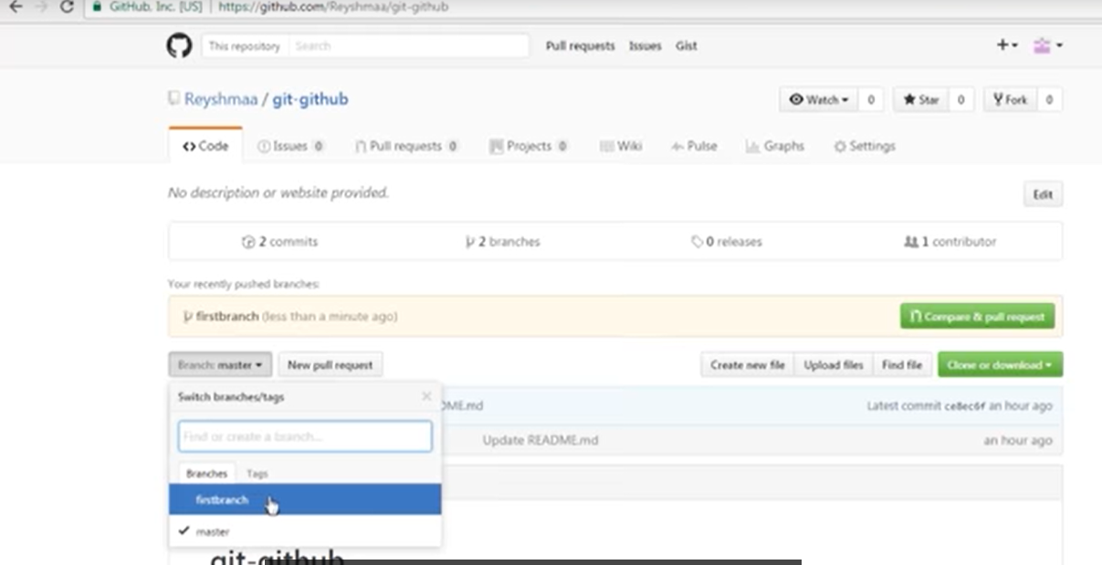

**Pushing local master branch to central master branch:**

* **switch to master branch in local**
* **git push origin master**

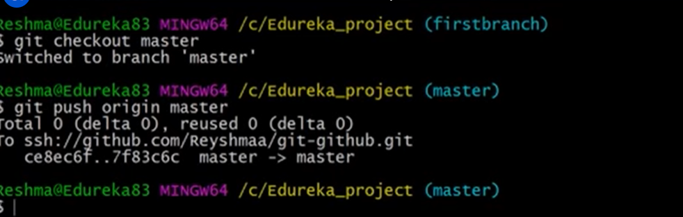

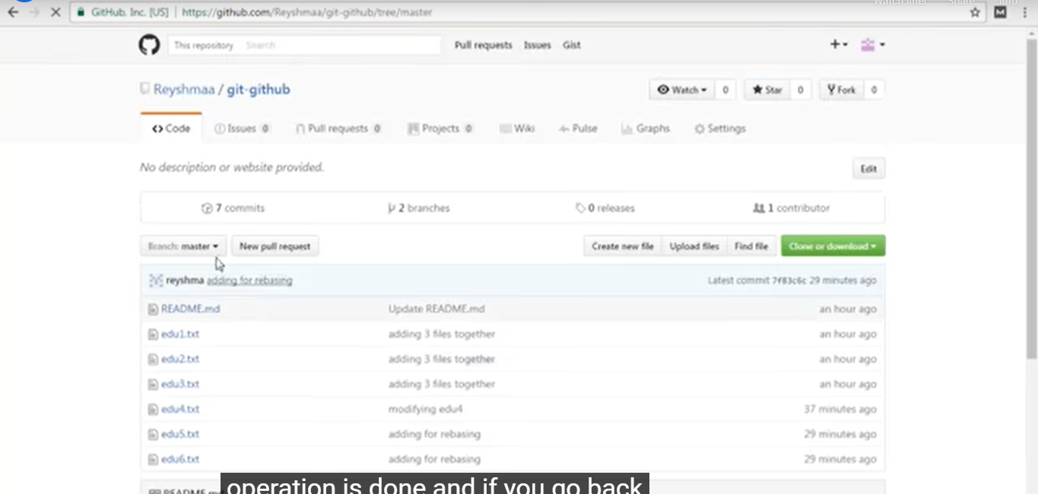

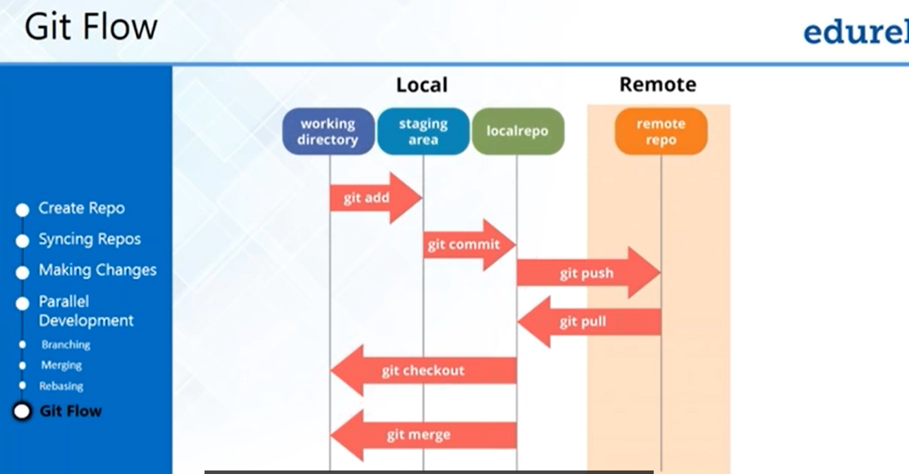

Roll back previous versions:

Accessing and modifying github repos using post man:

* Create a bearer token in developer settings under personalized tokens
* Go to github rest api documentation and find the link called endpoint for gitapps
* Then select repos link
* And use your desired operartion

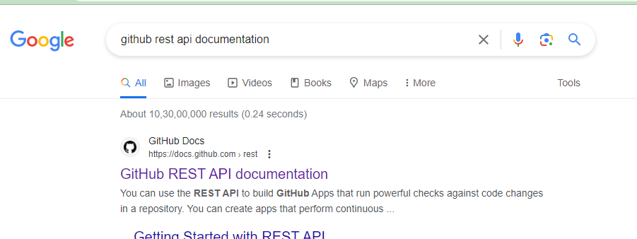

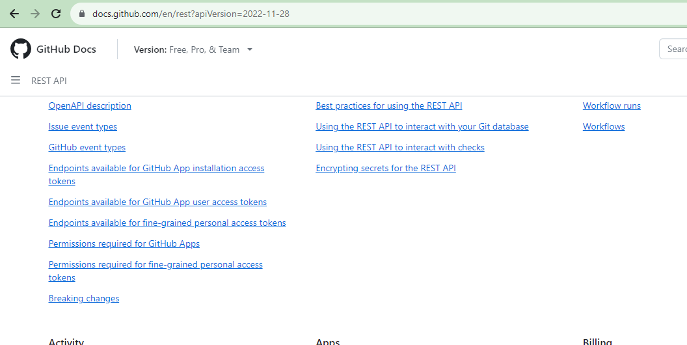

Use Endpoints available for Github app use access tokens



